**About the Data**

H&M data includes products and transactions data that is in the public domain. It is de-normalized and is obfuscated for the purpose of publishing online. Considering the data as initial set of data, we need to model ER diagram and generate a normalized data model used by the brand. Since, we have a requirement of customer size specific data and fabric details of product. This data is not present in the dataset. Therefore, we had to take 2-3 external datasets and merge them to get different body measurements of customers and fabric types of products. Also, since our idea is novel based on different style, such kind of data is not present so we had to look for different style types and generate the data according to our requirement. We have made the data models to address the following use cases which can be generalized for any brand in the market.

**USE CASES**

**Assumptions**

Registration and login is out of scope.

1. Customer
2. Assumption is that Customer has registered by providing relevant body measurements such as bust, hips, waist, high hip.
3. Customer has given his/her skin condition level

Skin condition level 1 indicates: Severe skin conditions (eczema. psoriasis)

Skin condition level 2 indicates: Mild skin conditions (dryness, itchiness)

Skin condition level 3 indicates: No skin issues

1. System should be able to evaluate the body type for each customer.
2. Each body type may have one or more product styles associated with it.
3. Product available in online store to its customers.
   1. Each product is divided into three categories
      1. Garment Upper Body
      2. Garment Lower Body
      3. Garment Full Body
   2. Each Product type is a part of one Product group. Product type can be Top, Blouse, Trouser, Skirt, Cardigan etc. (1-1)
   3. Each product can be of one product type. (1-1)
   4. Each product may have one or more colors associated with it. Also, each color may be associated with one or more products.(M-M)
   5. A product can compose of multiple fabrics. Also, multiple products can be made from each fabric. (M-M)
   6. Each product may have one or more styles associated with it. Also, each style can be found in one or more products. (M-M)
   7. A style for particular body should match the style associated with the product type.
   8. Each fabric should have a level indicating:
      1. Fabric level 1: Highest quality (skin-level 1 can wear these)
      2. Fabric level 2: Medium quality (skin-level 2 can wear these + fabric level 1)
      3. Fabric level 3: Lowest quality (skin-level 3 can wear these + fabric level 1 + fabric level 2)

**ER Diagram**

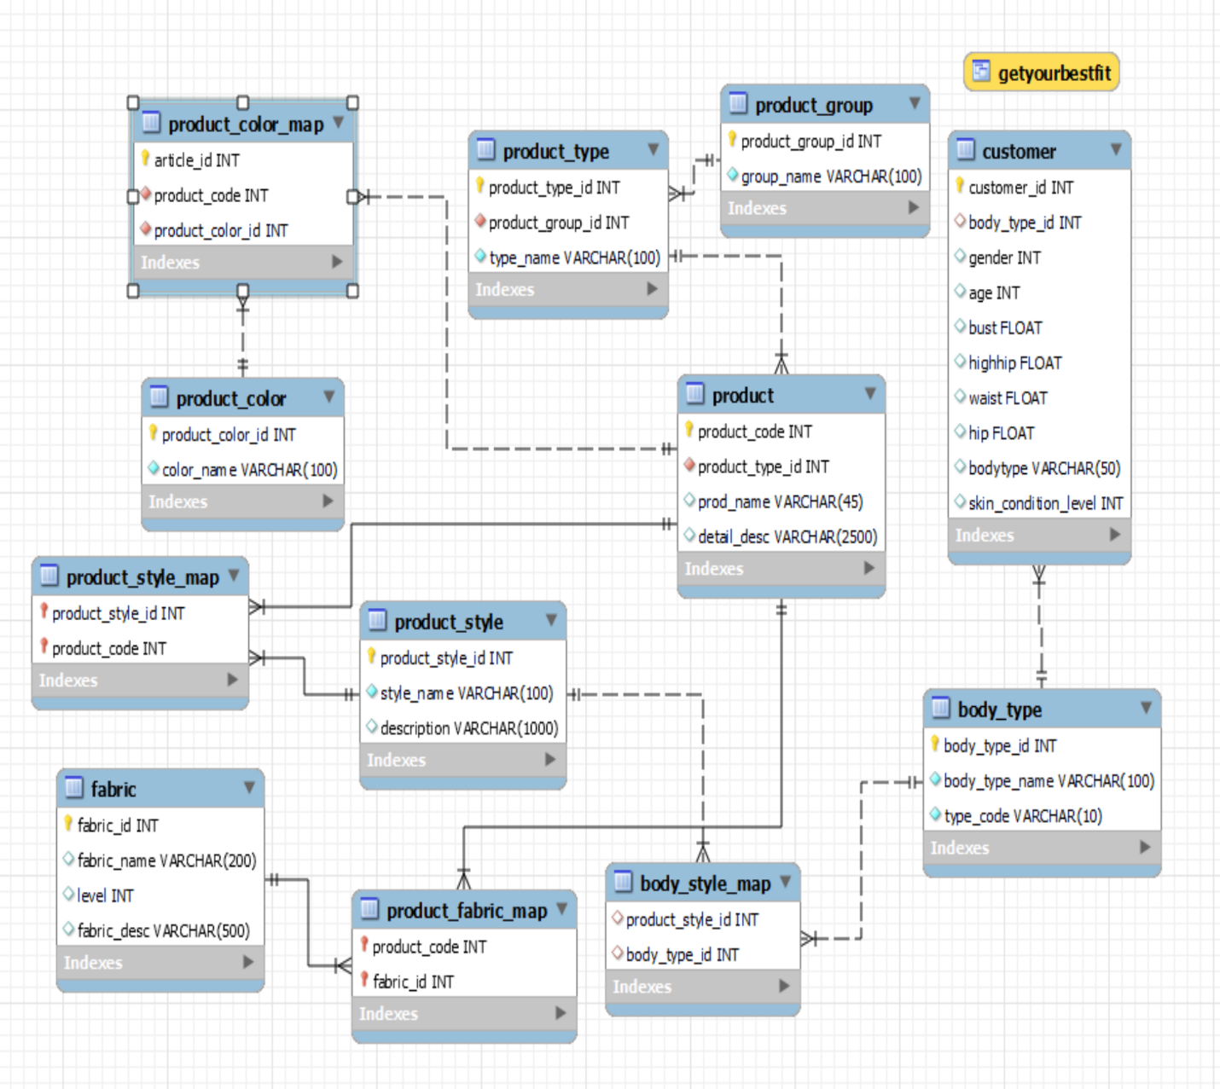

1. Customer creates the profile.
2. Profile contains following information
3. Name
4. Email Address
5. Phone contact
6. Shipping address
7. Mail address
8. Height
9. Weight
10. Skin Tone
11. Body Shape
    1. rectangle
    2. inverted triangle
    3. hourglass
    4. pear
    5. apple
12. Skin Condition
13. Skin condition can be categorized into
    1. No condition
    2. Mild allergy
    3. Severe allergy
14. Product Information:
    1. Gender
       1. Men
       2. Women
       3. Boys
       4. Girls
       5. Toddlers
       6. Infants
    2. Product category
       1. Formal
       2. Party
       3. Casual
       4. Nightwear
       5. Office
       6. Wedding
       7. Athleisure
       8. Sportswear
       9. Innerwear
    3. Product_Type